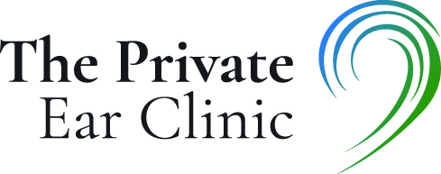

T&Cs for NHS/Forces Discount

To be able to qualify for an NHS/Forces discount the client needs one of the following-
- A registered and in date Blue Light card, available at www.bluelightcard.co.uk
- A registered and in date Defence Discount Card, available at www.defencediscountservice.co.uk

Terms of using discount-
- A valid ID MUST be shown at every appointment, without this, no discount will be offered.
- Proof of discount we can accept include the following-
- Physical discount card
- Either the Blue Light or Defence Discount App on your phone, clearly showing your card with the correct name and valid date.
- Discount card stored in ‘wallet’ on your phone; we can accept this, but again, it must show a valid name and be in date.
- We can accept a clear photo of the card, but only if the name and expiry date are clear to read.
- Discount is only applicable to person named on the card, not family members (including children) or friends.
- Work ID cannot be accepted
- £10 discount only valid for wax removal, it does not apply to any other service we provide.
- Discount will not be given to any client who previously worked in NHS/Blue light/military services, if they do not present a valid and in date ID card.
- The discount cannot be used in conjunction with any other discount/promotion scheme we offer.
- The Private Ear Clinic reserves the right to withdraw the discount at any time, without notice.

